香港特別行政區政府海事處

MARINE DEPARTMENT
THE GOVERNMENT OF THE HONG KONG SPECIAL ADMINISTRATIVE REGION

綠色船用燃料加注獎勵計劃申請表

Application for Green Maritime Fuel Bunkering Incentive Scheme

GUIDANCE NOTES 填表須知
- Please read the Introduction of the Green Maritime Fuel Bunkering Incentive Scheme and the Personal Data Collection Statement at the end of this application form before completing the form. 填寫本表格前，請參閱綠色船用燃料加注獎勵計劃簡介及本申請表最後的「收集個人資料聲明」。
- Completed application form together with copies of all supporting documents may be submitted to the Green Maritime Fuel Team either by post (Marine Department, 21/F, Harbour Building, 38 Pier Road, Central, Hong Kong) or e-mail (greenfuel@mardep.gov.hk). For any enquiries related to the application, please contact the Green Maritime Fuel Team via the same email. 填妥後的申請表和所有證明文件副本可以郵寄綠色船用燃料小组（香港中環統一碼頭道 38 號海港政府大樓 21 樓）或電郵(greenfuel@mardep.gov.hk)方式遞交。若對申請有任何疑問，亦可通過上述電郵聯絡綠色船用燃料小组。
- The incentive will be made to the successful applicant by direct credit to the bank account. Please fill in the "AUTHORITY FOR PAYMENT TO A BANK" Form (GF179A) as attached in Appendix 1. For other disposal methods, please contact the Green Maritime Fuel Team. 獎勵將直接存入成功申請人指定接收款項的銀行帳戶。請填寫附件1的「授權銀行付款」表格（GF179A）。如需使用其他方式，請聯絡綠色船用燃料小组。
- The Marine Department reserves the right of final decision on the approval of incentive. 本處保留審批獎勵的最終決定權。

- Particulars of Applicants 甲部 ─ 申請人資料
Company Name
公司名稱
Company Registration No. & Business Registration Certificate (if applicable)
公司編號及商業登記 （如適用）
Address
地址
Contact Person
聯絡人
Job Title
職銜
Tel. No.  電話號碼 |  |  | Mobile Phone No.  流動電話號碼
Fax No.  傳真號碼 |  |  | Email Address  電郵地址

Role / 身份  Tick as appropriate  請在適當方格內加上「」號 | Bunker Supplier 燃料供應商  Bunker Vessel Management Company 燃料加注船舶管理公司  Agent 代理人  Others (Please specific)  其他(請指明)_____________________________

- Particulars of Ship to Ship Bunker Operation 乙部 — 船對船燃料加注資料
Number of bunkering operations / 加注次數  Tick as appropriate  請在適當方格內加上「」號 |  | 1. First Bunkering Operation 首次加注作業  2. Second Bunker Operation 第二次加注作業
Date of commencement of Bunkering Operation  加注作業開始日期 | 1.  2. |  | Location of Bunkering Operation  (e.g. South Cheung Chau Anchorage)  加注作業地點(例如:長洲南錨地) | 1.  2.
Name of Bunker Vessel  燃料加注船名稱 | 1.  2. |  | C.O.O Number of Bunker Vessel  燃料加注船的擁有權證明書號碼 | 1.  2.
Name of Receiving Vessel  燃料接收船名稱 | 1.  2. |  | IMO Number of Receiving Vessel  燃料接收船的國際海事組織編號 | 1.  2.
Bunker Fuel Type and Volume  加注燃料種類及加注量 | LNG 液化天然氣,  - ________________ metric tons 公噸  - ________________ metric tons 公噸  Green Methanol 綠色甲醇, ________________metric tons 公噸  - ________________ metric tons 公噸  - ________________ metric tons 公噸

- Documents submitted 丁部 — 提交的文件
- Copy of Bunker Delivery Note燃料交付單副本
- Copy of Company Registration No. & Business Registration Certificate (if applicable) 公司註冊號碼及商業登記副本（如適用）
- Supplementary document for having a Hong Kong-registered subsidiary (if applicable)香港註冊子公司擁有權補充文件 (如適用)
- Supplementary document on ownership or chartering agreement of bunker vessel (whichever is applicable) 燃料供應船擁有權或租賃協議補充文件(適用者為準)

- Declaration 戊部 — 聲明
- I confirm that I am authorised to make and sign this application. 本人現確認本人已獲授權作出及簽署此項申請。
- I confirm that I have not previously made a separate application for the relevant bunkering operation stated under this application nor received an incentive under the Scheme for the concerned bunkering operation. 本人現確認此前並未為本申請涉及的燃料加注在此計劃下另作申請或獲得獎勵。
- I confirm that the copy of the Bunker Delivery Note provided has not previously been used for making a separate application nor received an incentive under the Scheme apply for and granted this incentive. 本人現確認所提供的燃料交付單副本此前未有用作在此計劃下另作申請或獲得獎勵。
- I declare that all the information and documents provided in this application are full, true and complete to the best of my knowledge and belief. 本人聲明就本人所知所信，在本申請表內所填報的各項資料及一併提交的文件均屬全面、真實及完整。
- I understand that if I give false or incorrect information intentionally, or forge any submitted documents, the application will no longer be eligible for incentives under the Scheme. I will have to refund any and all incentive received, and the Government reserves the right to recover by civil action all incentive granted and conduct relevant criminal investigation. 本人明白如蓄意提供虛假或不正確資料，或偽造提交的文件，此申請即喪失接受本計劃獎勵的資格。本人須退回任何及所有已收到的獎勵，同時政府保留權利循民事程序追回全部已發放的獎勵及作出相關刑事調查。
- I understand that the application will not be processed if I fail to provide all the requested information. 本人明白若未能按要求提供所有資料，此申請將不獲處理。
- My acceptance of the incentive indicates my agreement to provide, where necessary, assistance and data to researches related to the Scheme conducted by the Government or its authorised agents. 若接受獎勵，即表示本人同意在有需要時提供協助及資料，予政府或其授權代理人作有關本獎勵計劃的研究。
- I agree that the data provided in this application can be used by the Government or other parties authorised by law for funding allocation and administrative purposes. I am aware that subject to exemptions under the Personal Data (Privacy) Ordinance, I have a right of access and correction with respect to the personal data submitted. Request for personal data access and correction can be addressed to the Green Maritime Fuel Team of the Marine Department. 本人明白在本表格內所提供的資料可被政府或法例賦權的其他機構用作撥款及行政用途。本人清楚在不抵觸《個人資料(私隱)條例》的豁免條文下，本人有權要求索閱及修正個人資料，並可向綠色船用燃料小组查詢，以索閱及修改個人資料。
- I have read, understood, and undertake to comply with the following clauses:
本人已閱讀丶明白及承諾遵守下列條款：
  - the Government reserves the right to disqualify this application on the grounds that the Applicant/Company has engaged, is engaging, or is reasonably believed to have engaged or be engaging in acts or activities that are likely to cause or constitute the occurrence of offences endangering national security, or otherwise the exclusion of the Applicant/Company from future applications under the Scheme is necessary in the interest of national security, or is necessary to protect the public interest of Hong Kong, public morals, public order or public safety;
政府保留權利以申請人/公司曾經參與、正在參與或有理由相信申請人/公司曾經或正在參與可能導致或構成發生危害國家安全罪行的行為或活動為由，取消申請人/公司的是次申請，又或為維護國家安全，或為保障香港的公眾利益、公共道德、公共秩序或公共安全，而有必要剔除申請人日後申請本計劃的資格。
  - even after the application is approved, the Government may immediately withdraw or cancel the relevant approval, and I have to repay to the Government all the incentive received from the application and the Government reserves the right to recover by civil action and I may be liable to prosecution upon the occurrence of any of the following events:
    - the Applicant/Company has engaged or is engaging in acts or activities that are likely to constitute or cause the occurrence of offences endangering national security or which would otherwise be contrary to the interest of national security;
    - the payment of incentive to the Applicant/Company is contrary to the interest of national security; or
    - the Government reasonably believes that any of the events mentioned above is about to occur.
即使有關申請已獲批准，如果出現下列任何一種情況，政府可立即撤回或取消有關批准，本人並須退回所有就此申請已收取的款項，同時政府保留權利循民事程序追 討及對本人提出檢控：
    - 申請人/公司曾經參與或正在參與可能會構成或導致發生危害國家安全罪行或不利於國家安全的行為或活動；
    - 向申請人/公司發放獎勵將不利於國家安全；或
    - 政府合理地相信上述任何一種情況將會發生。

Signature of Applicant 申請人簽署  For company, please affix the company seal/stamp 如屬公司，請加蓋公司印章。 | ____________________________________________
Date 日期 | ____________________________________________

For Official Use Only 本處專用

Application for incentive 申請優惠
Approved 批准
Rejected 拒絕 (Reason 理由:) _____________________________________________________

Name and Signature of Authorized Officer 獲授權人員姓名及簽署
________________________
Date 日期 _______________________

Personal Data Collection Statement  - Purposes of Collection  The personal data provided by means of this form will be used by Marine Department for the following purposes:  - activities relating to the processing of your application in this form;  - facilitating communication between Marine Department and yourself; and  - for statistics and research purposes, on the condition that the resulting statistics or results will not be made available to the public in a form which will identify the data subjects.  - Classes of Transferees  The personal data you provided by means of this form may be disclosed to other Government Bureaux and Departments for the purposes mentioned in paragraph 1 above.  - Access to Personal Data  You have a right of access and correction with respect to your personal data, as provided for in Sections 18 and 22 and Principle 6 of Schedule 1 of the Personal Data (Privacy) Ordinance. Your right of access includes the right to obtain a copy of your personal data provided by this form.  - Enquires  Enquiries concerning the personal data collected by means of this form, including any application for access and correction, should be addressed to:  Green Maritime Fuel Team  Marine Department,  21/F, Harbour Building, 38 Pier Road,  Central, Hong Kong | 收集個人資料聲明  - 收集目的  海事處會使用透過本申請表所獲得的個人資料作下列用途：  - 辦理有關你在本申請表中所提出的申請的事務；  - 方便海事處與你聯絡；以及  - 供作統計及研究用途，但所得的統計數字或研究成果，不會以能辨識各有關資料的當事人或其中任何人的身份的形式公開披露。  - 獲轉交資料的部門╱人士  你透過本申請表所提供的個人資料會向其他政府部門、決策局及有關機構，以作上述第 1段所列的用途。  - 索閱個人資料  根據《個人資料(私隱) 條例》第 18 及 22 條及附表 1 第 6 條，你有權索閱及修正你的個人資料。你的索閱權包括獲取本申請表所提供的個人資料副本一份。  - 查詢  有關透過本申請表收集的個人資料的查詢，包括索閱及修正資料，應寄往：  綠色船用燃料小组  香港統一碼頭道 38 號  海港政府大樓 21 樓

Appendix 1 附件1
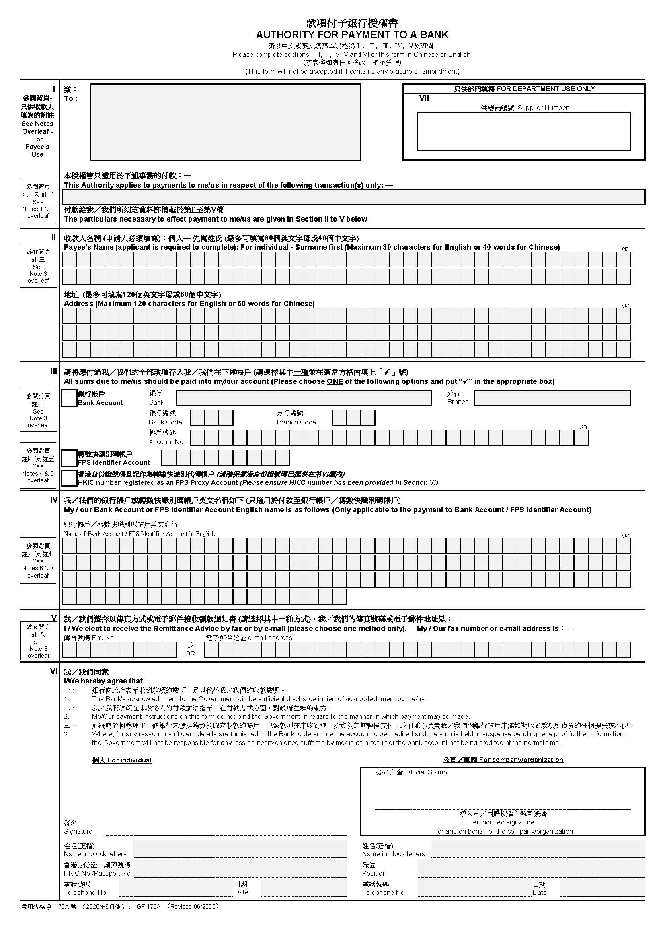
海事處
Marine Department
Appendix 1 附件1

